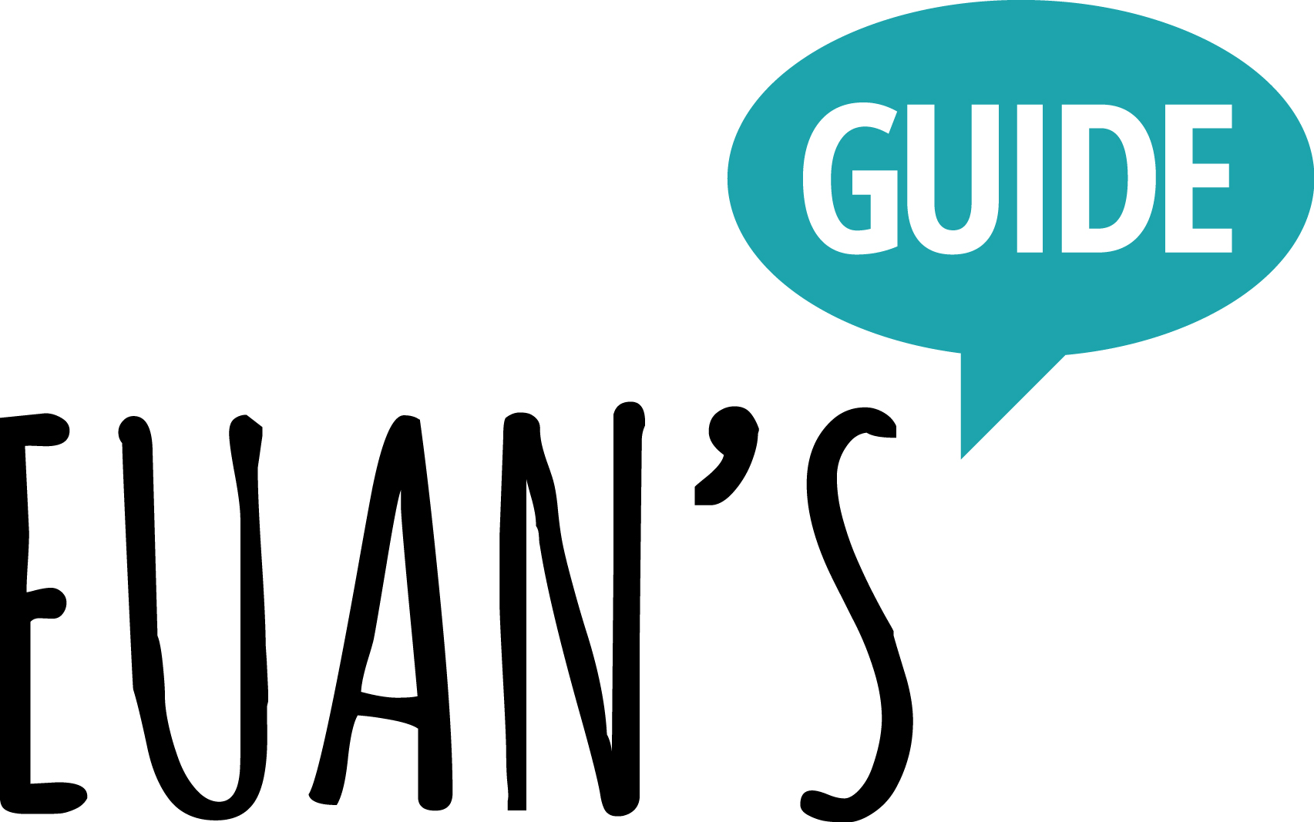

The Euan's Guide Access Survey 2022

Supported by Motability Operations Ltd

Large Print Version

Results Published March 2023

Contents

Hello and Welcome!
The Access Survey Summary
Full Results
About Euan’s Guide
About The Motability Scheme and Motability Operations

Hello, and welcome!

2022 was the eighth Access Survey by the award-winning disabled access charity Euan’s Guide, and the second year that the survey has been supported by Motability Operations, the company behind the Motability Scheme.

Our partnership means we’ve been able to reach more people than ever before with over 7,500 people taking part, reinforcing our survey as the largest of its kind in the UK.

The Cost of Living Crisis was a key element of the 2022 Access Survey, as even when we were planning the survey back in Summer 2022 we knew that it was already having a disproportionate impact on our community of disabled people, friends, families and carers.

Key findings related to the Cost of Living Crisis have been published and are available at https://www.euansguide.com/cost-of-living-crisis/. The full results are included in the Access Survey results which follow.

The main focus of our annual Access Survey continues to be giving those with experience of disabled access an opportunity to share their views. The 2022 Access Survey results found that disabled people are being excluded from everyday activities because of a lack of disabled access information.

Our research shows that 72% of respondents have found accessibility information on a venue’s website to be misleading, confusing or inaccurate, with a further 74% of
participants also reported having experienced a disappointing trip or having had to change plans due to poor accessibility.

Euan’s Guide was set up to combat this problem. Our website, EuansGuide.com, is a place for disabled people to find and share disabled access information. It’s clear that first-hand experiences and peer-to-peer reviews are a trusted source of information for disabled people, with 51% of survey respondents reporting that reviews from other disabled people improve their confidence when visiting new places, and 46% said they’ve visited somewhere new after reading a review on EuansGuide.com.

Information continues to be key, with a huge 91% of respondents telling us they try to find disabled access information about a new place before visiting, with 58% saying they avoid going to a venue if it has not shared its disabled access information because they assume it’s inaccessible.

Respondents continue to tell us that the top accessible facilities they need to improve their confidence to visit new places were accessible parking (80%) and accessible toilets (76%).

Thank you to everyone who took part and shared their experiences!

www.euansguide.com | hello@euansguide.com | +44 (0)131 510 5106 CodeBase, Argyle House, 3 Lady Lawson Street, Edinburgh, EH3 9DR, UK
Euan’s Guide is a charity registered in Scotland (SCO45492) @EuansGuide

The Access Survey – Summary

- 72% found accessibility information on a venue’s website to be misleading, confusing or inaccurate
- 74% have experienced a disappointing trip or having had to change plans due to poor accessibility.
- 91% try to find disabled access information before visiting a new place
- 58% avoid going to a venue if it has not shared its disabled access information because they assume it’s inaccessible.
- 51% said reviews from other disabled people improve their confidence when visiting new places
- 46% have visited somewhere new after reading a review on EuansGuide.com
- Top accessible facilities needed to improve confidence when visiting new places were accessible parking (80%) and accessible toilets (76%).

- The Euan’s Guide Access Survey supported by Motability Operations Ltd was conducted in Autumn 2022.
- There were over 7,500 respondents and 98% respondents self identified as a disabled person.

www.EuansGuide.com/AccessSurvey

Full Results

Cost of Living

How have rising costs impacted you on a daily basis?

They have not impacted me on daily basis 9%
I have started to make different choices when buying things 81%
I have a bigger debt 16%
I’m in debt for the first time 7%

Please tell us about your energy bills

I am not concerned about my energy bills 3%
I am concerned about my energy bills 57%
I am cutting back on my energy usage 68%
I am using the same amount of energy 7%
I am using more energy 5%
Not applicable to me 1%

Please tell us about your grocery bills?

I am not concerned about my grocery bills 5%
I am concerned about my grocery bills 55%
I am cutting back on groceries spending 65%
I am buying the same amount of groceries 12%
I am buying more groceries 1%
Not applicable to me 1%

Please tell us about your vehicle costs?

I am not concerned about my vehicle costs 12%
I am concerned about my vehicle costs 44%
I am cutting back on vehicle costs 34%
I am spending the same on my vehicle costs 12%
I am spending more on my vehicle costs 19%
Not applicable to me 6%

Please tell us about your participation in leisure and recreation activities?

I am doing more than I was before 2%
I am doing as much as I was before 16%
I am doing less than I was before 55%
I am spending more on leisure and recreation 5%
I am spending the same on leisure and recreation 6%
I am spending less on leisure and recreation 34%

COVID

In terms of Covid..

You (or someone you live with) were shielding 50%
You (or someone you live with) are currently shielding? 6%
You (or someone you live with) are currently taking Covid precautions when out and about 44%
None of the above 24%

In terms of Covid..

I am less likely to visit new places 59%
I am just as likely to visit new places 37%
I am more likely to visit new places 4%

Disabled Access

In the past year, do you feel that there has been any change to overall levels of access for disabled people in the UK?

Access has improved 5%
Access has stayed the same 56%
Access has got worse 36%

Thinking about accessibility, how confident are you about visiting new places?

Very confident 2%
Moderately confident 18%
Neither confident nor unconfident 24%
Moderately unconfident 33%
Very unconfident 22%

What would help improve your confidence when visiting new places?

Accurate disabled access information 72%
Easily available disabled access information 65%
Local disabled access information when out and about 52%
Recommendations from friends or family 25%
Reviews from other disabled people 51%
Easy and accessible transport links 33%
Accessible parking 80%
Accessible toilets 76%
Changing Places toilet 15%

When visiting a new place, do you try to find disabled access information about it beforehand?

Yes 91%
No 8%

If yes, how do you find this information?

I contact the venue directly 41%
I check their website 85%
I ask friends, community groups or other people 19%
I use Euan’s Guide 9%
I search the internet 51%

If you have used a venue’s website to check disabled access before visiting, have you ever found the information to be misleading, confusing or inaccurate?

Yes 72%
No 28%

Have you ever experienced a disappointing trip or had to change your plans because of poor accessibility?

Yes 74%
No 26%

What are the barriers to access that you commonly find when out and about?

I couldn’t get into the venue (e.g. lack of automatic doors, ramp or directions) 41%
I couldn’t get around the venue (e.g. lack of lifts, narrow corridors, too little space or poor layout) 57%
I was not able to participate in the same way as others (e.g. can’t take part in the activity) 47%
The environment made me uncomfortable (e.g. too loud, bright or overstimulating) 25%
The facilities weren’t what I expected (e.g. lack of hoist, faulty equipment, broken lift) 34%
There were no alternative formats to suit my requirements 18%
There was no access to a toilet that suits my requirements 37%
Staff attitudes or not getting the required assistance from staff 36%
Staff being unsure how to work equipment (e.g. such as portable ramps, hearing loops) 16%
A lack of accessible transport options to the venue 21%
A lack of appropriate parking available 61%

I am more likely to visit somewhere new if...

I can find relevant access information about the venue 73%
I feel welcomed by staff or the venue appears to care about accessibility 65%
It has been recommended to me by someone with similar requirements 54%
I can see pictures and read what others have said beforehand 58%

If a venue has not shared its disabled access information I...

Avoid going because I assume it is inaccessible 58%
Phone or email the venue to check accessibility 47%
Check Euan’s Guide to see if it has been reviewed 10%
Take a chance and go anyway 12%

How likely are you to share your experiences of disabled access with others?

Very likely 47%
Moderately likely 28%
Neither likely nor unlikely 17%
Moderately unlikely 4%
Very unlikely 4%

When somewhere has good accessibility do you...

Tell the venue 51%
Tell others about it 66%
Make a return visit 72%
Review it on Euan’s Guide 5%
Share it on social media 24%

When somewhere has bad accessibility do you...

Tell the venue 51%
Tell others about it 66%
Review it on Euan’s Guide 5%
Share it on social media 24%

What is your main mode of transport?

Car – owned or leased 94%
Car – lifts from friends or family 13%
Bus or Tram 11%
Taxi 13%
Train or Underground 10%
Bicycle 0%
E-Bike 1%
Powerchair or scooter – Powerchair 13%
Scooter 26%
Walking 9%

In your experience, how would you rate the accessibility of the following types of places?

Pubs and bars

- Most are excellent 4%
- Most are good 25%
- Most are average ﻿36%
- Most are poor ﻿15%
- Most are very poor ﻿4%
- Don't know ﻿16%

Cafes and Restaurants

- Most are excellent ﻿4%
- Most are good ﻿31%
- Most are average ﻿43%
- Most are poor ﻿14%
- Most are very poor ﻿3%
- Don't know ﻿5%

Shops

- Most are excellent ﻿6%
- Most are good ﻿35%
- Most are average ﻿38%
- Most are poor ﻿15%
- Most are very poor ﻿4%
- Don't know ﻿2%

Museums and art galleries

- Most are excellent ﻿10%
- Most are good ﻿32%
- Most are average ﻿20%
- Most are poor ﻿5%
- Most are very poor ﻿1%
- Don't know ﻿33%

Historic attractions

- Most are excellent 3%
- Most are good 19%
- Most are average 27%
- Most are poor 17%
- Most are very poor 6%
- Don't know 28%

Visitor attractions

- Most are excellent 4%
- Most are good 26%
- Most are average 35%
- Most are poor 10%
- Most are very poor 3%
- Don't know 23%

Cinemas and theatres

- Most are excellent 9%
- Most are good 33%
- Most are average 24%
- Most are poor 10%
- Most are very poor 3%
- Don't know 21%

Concert halls and music venues

- Most are excellent 5%
- Most are good 22%
- Most are average 23%
- Most are poor 11%
- Most are very poor 4%
- Don't know 36%

Events and Festivals

- Most are excellent 2%
- Most are good 11%
- Most are average 15%
- Most are poor 14%
- Most are very poor 6%
- Don't know 48%

Hotels

- Most are excellent 7%
- Most are good 34%
- Most are average 32%
- Most are poor 9%
- Most are very poor 2%
- Don't know 15%

Sporting Stadiums

- Most are excellent 4%
- Most are good 14%
- Most are average 15%
- Most are poor 67%
- Most are very poor 3%
- Don't know 57%

Leisure and Sports Centres

- Most are excellent 4%
- Most are good 21%
- Most are average 15%
- Most are poor 6%
- Most are very poor 2%
- Don't know 46%

Transport hubs (e.g. airports and train stations)

- Most are excellent 6%
- Most are good 26%
- Most are average 25%
- Most are poor 13%
- Most are very poor 6%
- Don't know 25%

Outdoor (e.g. parks, trails and nature reserves)

- Most are excellent 4%
- Most are good 23%
- Most are average 32%
- Most are poor 18%
- Most are very poor 7%
- Don't know 18%

Hospitals and healthcare venues

- Most are excellent 21%
- Most are good 46%
- Most are average 23%
- Most are poor 6%
- Most are very poor 2%
- Don't know 2%

Public and council buildings

- Most are excellent 6%
- Most are good 31%
- Most are average 32%
- Most are poor 9%
- Most are very poor 3%
- Don't know 19%

Accessible Toilets

Have you ever come across an accessible toilet that you were unable to use?

Yes 65%
No 33%

What are the most common problems you encounter with accessible toilets?

Not enough space 41%
The layout 30%
Wheelchair transfer space obstructed 22%
Too many things in the way making it difficult to manoeuvre 31%
Dirty 64%
Not having the right equipment or it has not been installed correctly 11%
Confusing signage 6%
Lack of visual contrast 4%
No tactile guidance 3%
Getting in and out 15%
No Changing Places facilities 11%
Don’t know 4%

Have you ever avoided going somewhere because...

You knew it didn’t have an accessible toilet 72%
You couldn’t find information about an accessible toilet 47%
You knew it didn’t have a Changing Places toilet 9%
You couldn’t find any information about a Changing Places toilet 13

Have you ever had to use an emergency cord to call for help?

Yes 10%
No 90%
About you
Where do you live?

England 79%
Scotland 11%
Wales 6%
Northern Ireland 3%

When ‘out and about’, most of the time you are...

With friends or family 74%
With an unpaid or family carer 29%
With a carer or PA 12%
By myself 26%
With a club or group 3%

Are you...

A disabled person 98%
Family member or friend of a disabled person 11%
Unpaid or family carer 7%
Carer or PA 2%
Of retirement age 17%
Teacher, Social Worker or Healthcare Professional 1%
I’d rather not say 0%

Do you use or have experience of:

Wheelchair 67%
Powerchair 19%
Mobility Scooter 42%
Walking Aid 67%
Symbol Cane 2%
Long Cane 5%
Assistance Dog - Visual Impairment 1%
Assistance Dog – Other 2%
Sign Language %
Hearing Aid or Cochlear Implant 12%
AAC 1%
Hidden Impairment 15%
Speech Impairment 5%
PMLD 1%
Autism 9%
Dementia 4%
Learning Disability 9%
Changing Places Toilet 8%

About Euan’s Guide

Euan MacDonald, founder of Euan’s Guide, said: “We’re delighted to be working with Motability Operations for a second year to amplify the voices and experiences of disabled people with the Access Survey, which is vital in establishing how disabled people feel about disabled access. This year the survey results inform us on how much work there is still to be done around communication and information sharing.

“Sadly, the data gathered has shown that businesses don’t fully appreciate how important it is to share their disabled access information. Businesses are undervaluing disabled people both in terms of social inclusion and spending power.

“We encourage disabled people to review the places they visit on EuansGuide.com and use the website to find first-hand experiences of disabled access at venues across the UK and beyond. Likewise, if you work at a venue, please promote your disabled access information in your own communications and by listing on EuansGuide.com for free.”

Euan’s Guide is the award-winning disabled access charity. We’re best known for EuansGuide.com, the disabled access review website with thousands of reviews written by disabled people for disabled people. The website is the go to tool for disabled people, their family, friends and carers to find and share disabled access information around the UK and beyond. We are a small but mighty charity who also make tens of thousands of accessible toilets safer through our Red Cord Card scheme and amplify our community’s voices by running the UK’s largest and longest running Access Survey.

The charity was founded in 2013 by Euan MacDonald MBE, a powerchair user and his sister Kiki after Euan was diagnosed with Motor Neuron Disease and a lack of disabled access made everyday experiences stressful. Having access to good quality disabled access information inspires confidence and removes the fear of the unknown. It breaks down the barriers of exclusion and makes it easier for disabled people to find great places to go.

@EuansGuide

www.euansguide.com | hello@euansguide.com | +44 (0)131 510 5106 CodeBase, Argyle House, 3 Lady Lawson Street, Edinburgh, EH3 9DR, UK Euan’s Guide is a charity registered in Scotland (SCO45492)

About Motability Operations and the Motability Scheme

Andrew Miller, CEO at Motability Operations, said: “Providing freedom and independence for disabled people is right at the heart of what we do at Motability Operations.

“We believe no disabled person should be left behind, so we’re pleased to support the Euan’s Guide access survey again this year and it’s great to see so many Motability Scheme customers have completed the survey. The insights that Euan’s Guide have shared are vital, and we hope that venues and other organisations take note and use them to improve disabled access across the country.’’

- The Motability Scheme is the UK’s leading car scheme for disabled people. It provides affordable, convenient, worry-free motoring to over 650,000 disabled customers and their families. Scooters and powered wheelchairs can also be leased through the Motability Scheme.
- The Scheme is available to anyone who receives the Higher Rate Mobility Component of the Disability Living Allowance, the Enhanced Rate of the Mobility Component of Personal Independence Payment, Enhanced rate mobility part of Adult Disability Payment (Scotland), Higher rate mobility component of Child Disability Payment (Scotland), the War Pensioners’ Mobility Supplement or the Armed Forces Independence Payment. Customers transfer their mobility allowance to Motability Operations Ltd to lease a car, scooter or powered wheelchair.
- The Motability Scheme is operated by Motability Operations Ltd, for over 40 years Motability Operations Ltd has worked to provide accessibility for millions of customers.
- By leveraging its purchasing power, Motability Operations Ltd ensures its customers benefit from affordable prices. Vehicle leases available on the scheme are 45% cheaper on average than alternate leasing options.
- Any profits generated by the Scheme are invested for the benefit of disabled people. This includes donations to Motability, the Charity so it can provide additional support such as grants to disabled people.
- When leasing a Motability Scheme car, customers enjoy insurance for three named drivers, servicing and maintenance, full RAC breakdown assistance, tyre and windscreen replacement and 60,000 mileage allowance over three years all included in the cost of the lease. A range of popular car adaptations are also available at no additional cost.
- When leasing a scooter or powered wheelchair, insurance, breakdown assistance, servicing, maintenance and repairs and tyre and battery replacement are all included in the cost of the lease. Pricing is standard nationwide.
- Motability Operations Ltd is authorised and regulated by the Financial Conduct Authority under reference number 735390.
- Motability is a Registered Charity in England and Wales (number 299745) and a Registered Charity in Scotland number SC050642, and is authorised and regulated by the Financial Conduct Authority (reference number 736309). Motability provides a range of scheme- related grants to individuals, who would otherwise be unable to afford the mobility solution they need.

