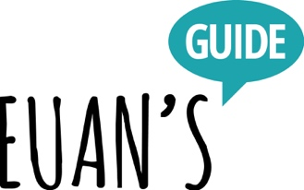

Access Statement for Euan’s Guide HQ

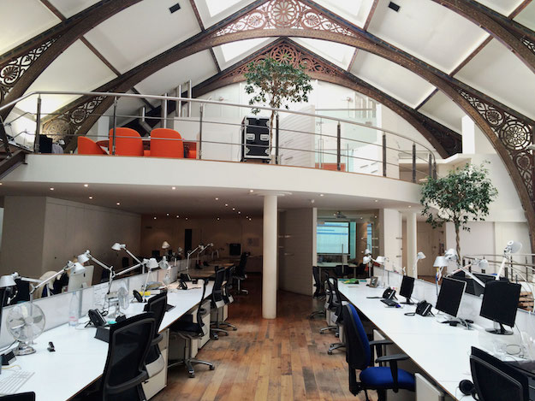

Photo showing the interior of the Creative Exchange.

Introduction

Euan’s Guide HQ is situated within the Creative Exchange in Leith, Edinburgh. The office is 3.1km (1.9 miles) from Waverley Railway Station. It takes around 42 minutes to walk here from the station or 8 minutes driving.

We look forward to welcoming you. If you have any queries of require any assistance, please phone us on 0131 510 5106 or email hello@euansguide.com.
Arrival

Euan’s Guide is located at 29 Constitution street, a spur off Bernard Street where the nearest bust stop is located. The Lothian Buses, part of Transport for Edinburgh, number 16 bus stops here and is equipped with a ramp and has space for one wheelchair. All Lothian Buses are wheelchair accessible. The pavements in the immediate vicinity are level with dropped kerbs in the appropriate places, and the road is cobbled.

All licensed taxis are wheelchair accessible and taxi drivers have undergone accessibility training.

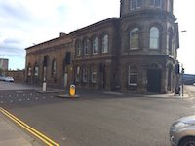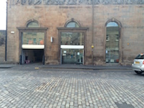
Photos showing the outside of the Creative Exchange.

Car parking and drop-off facilities

On-street parking is available and it is usually possible for find a space near the office. The Creative Exchange also has a private indoor car park which you may phone ahead to use. The kerb is 14 cm (5.5”) high in the street. Visitors can be dropped off outside the office. Wheelchair users may find it easier to be dropped off by the front door access where there is a dropped kerb.

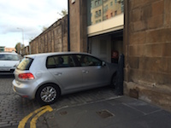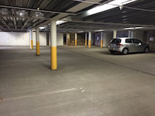
Photos showing entrance to and interior of car park.
Entrance

The main entrance is barrier free and the door is clear glass and quite heavy. To enter the building, there is an intercom set-up at the right-hand side of the main entrance. The receptionist is able to see visitors as they approach and can help with the door. There is a second clear glass door upon entry which leads you to the front reception desk. The receptionist will escort you to the Euan’s Guide office or somebody will come and meet you.

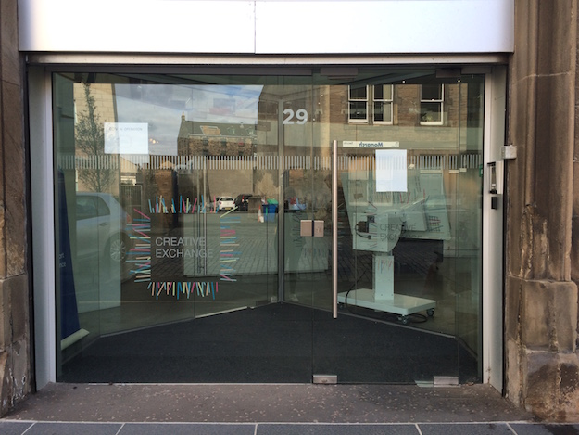

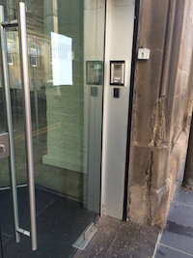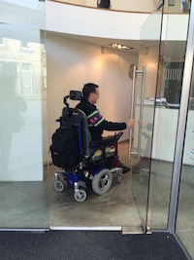
Photos showing the entrance and intercom.

If you have arranged to use the indoor car park, somebody will come and meet you at the interior entrance to the rear of the car park.
Inside the office

Euan’s Guide HQ is a spacious room with desks positioned in the middle of the room. The floor is carpeted and level throughout and there is ample circulation space around the desks for more than one wheelchair user. The main office is lit by fluorescent lights. Staff are happy to assist visitors where necessary.

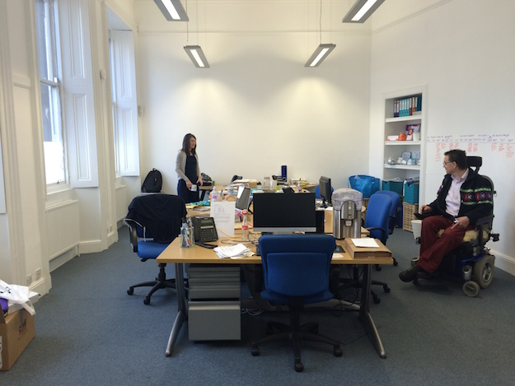
Photo showing the Euan’s Guide office.

Meeting rooms

Meeting rooms and spaces are available on request throughout the Creative Exchange. Meeting rooms on upper levels may be accessed via stairway or lift. There are meeting spaces in the reception foyer on the ground floor.

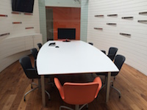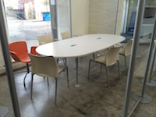

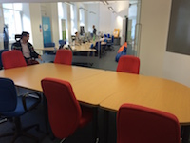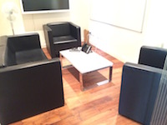

Photos showing four different meeting spaces within the Creative Exchange.

Accessible toilet

There is an accessible toilet on the ground floor. The door clearance is 85cm (33.46”). The room length is 210cm (82.67”) and the width is 150cm (59.05”).

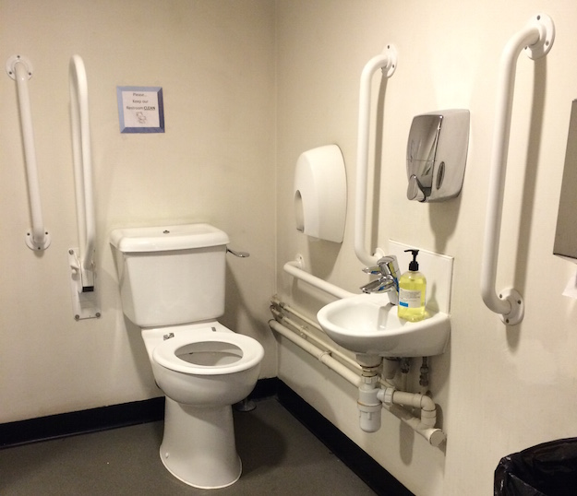
Photo showing the inside of the accessible toilet.

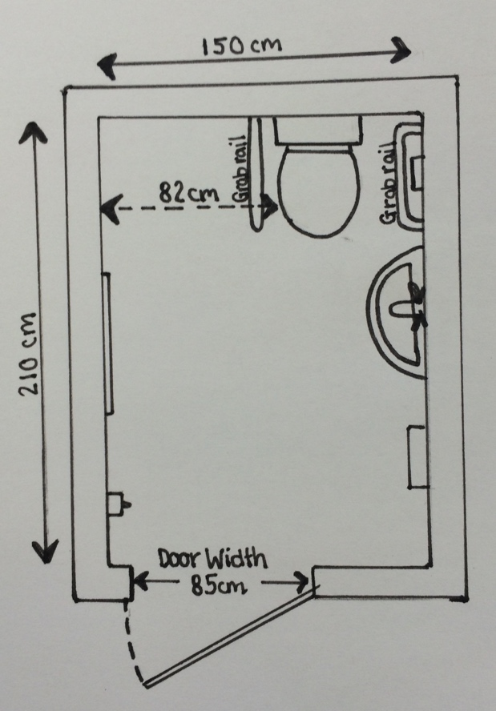
Floor plan and dimensions of the accessible toilet.
Lifts

There is one lift in the building which covers the first and second floors where meeting rooms are located. The door clearance on the lift is 80cm (31.49”) and there are side rails within the lift.

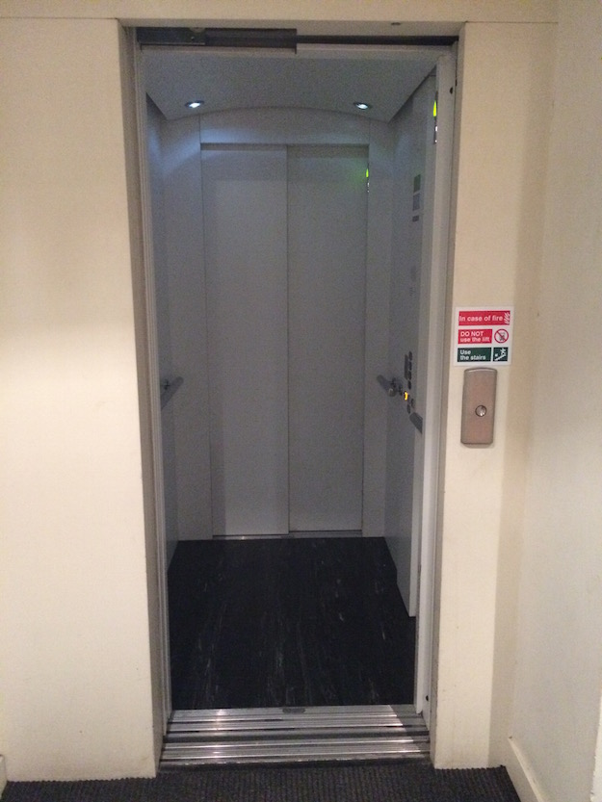
Photo showing the inside of the lift.

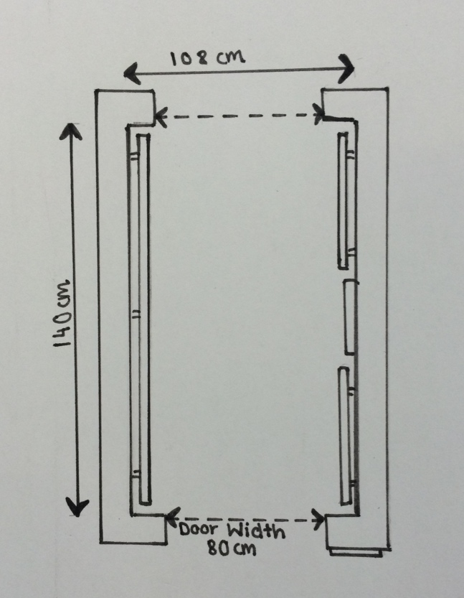
Floor plan and dimensions of the lift.
Additional Information

- There are power points for electronic devices, should they be required by visitors.
- A power point is available for powerchair users who wish to plug in their battery charger.
- We welcome assistance dogs and water bowls can be provided.
- If you require any of our information in an alternative format, please contact us.

Contact Information

Address: 29 Constitution Street, Edinburgh, EH6 7BS

Telephone: 0131 510 5106

Email: hello@euansguide.com

Website: www.euansguide.com

Hours: 10 am - 4 pm Monday – Friday

Transport contacts

City Cabs: 0131 228 1211

Central Taxis: 0131 229 2468

Local Bus: Lothian Buses number 16

This access statement does not contain personal opinions as to our suitability for those with access needs, but aims to accurately describe the facilities and services that we offer all our guests/visitors.

Last updated – August 2015

If you require this information in an alternative format, please contact us at hello@euansguide.com or telephone us on 0131 510 5106.

