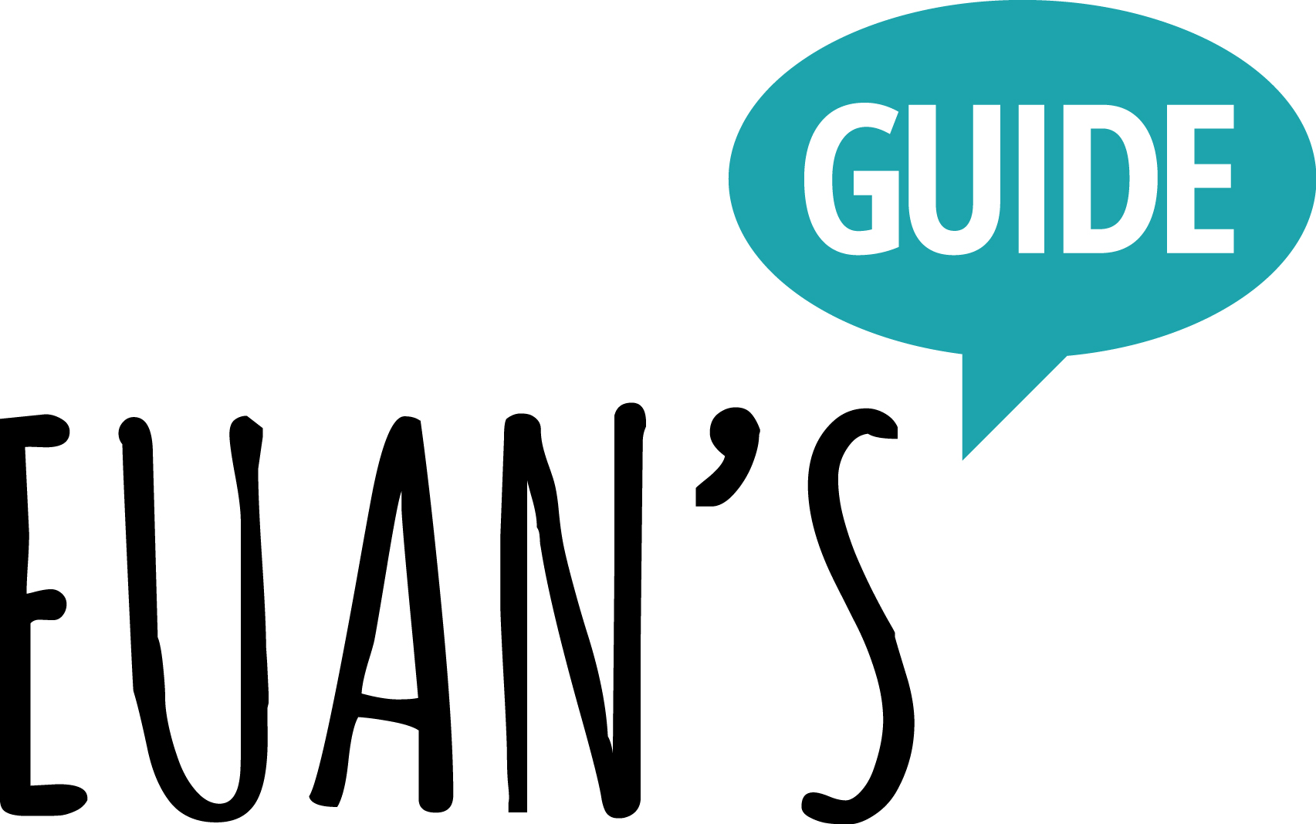

The Euan's Guide Access Survey 2023

Supported by Motability Operations Ltd

Large Print Version

Results Published February 2024

Contents

Hello and Welcome!
The Access Survey Summary
Full Results
Conclusion

Hello, and welcome!

2023 was the ninth annual Access Survey by the award-winning disabled access charity Euan’s Guide, and the third year that the survey was supported by Motability Operations, the company behind the Motability Scheme.

Our partnership means we’ve been able to reach over 6,000 people who took part in the survey this year, reinforcing the Euan’s Guide Access Survey as the largest of its kind in the UK.

The cost of living crisis was a key element of the survey for a second year, showing that our community of disabled people, their families, friends and carers, are still being disproportionately affected. In response to the Access Survey, 61% said they are cutting back on their energy usage and 50% said they are concerned about their energy usage.

The full results of the Access Survey, including cost of living and disabled access, have been published and are available at https://www.EuansGuide.com/AccessSurvey. Key findings are included in this document.
The focus of the Access Survey continues to be to give people with experience of disabled access an opportunity to share their views. The 2023 Access Survey results found that the research shows that:

- 91% of respondents said they try to find disabled access information before visiting a new place, yet

- 76% said they’ve found the information on a venue’s website to be misleading, confusing or inaccurate.
- 86% said they check a venue’s website before visiting a new place, yet 79% said they’d experienced a disappointing trip or had to change their plans because of poor accessibility.
- 59% said that if a venue has not shared its disabled access information they avoid going because they assume it is inaccessible.

Euan’s Guide was set up to combat the problem of poor or unavailable disabled access information. The website, www.EuansGuide.com, is a place for disabled people to find and share disabled access information.Euan’s Guide is grateful to everyone who took part in this year’s Access Survey – thank you!

www.euansguide.com | hello@euansguide.com | +44 (0)131 510 5106 CodeBase, Argyle House, 3 Lady Lawson Street, Edinburgh, EH3 9DR, UK
Euan’s Guide is a charity registered in Scotland (SCO45492) @EuansGuide

The Access Survey – Summary

The Euan’s Guide Access Survey
supported by Motability Operations
Ltd was conducted in Autumn 2023.

There were over 6,000 respondents and 98% respondents self identified as a disabled person.

- 76% found accessibility information on a venue’s website to be misleading, confusing or inaccurate
- 79% have experienced a disappointing trip or having had to change plans due to poor accessibility.

- 91% try to find disabled access information before visiting a new place
- 59% avoid going to a venue if it has not shared its disabled access information because they assume it’s inaccessible.
- 77% are more likely to visit somewhere new if they can find relevant access information
- 76% said accurate disabled access information improves confidence when visiting somewhere new
- 62% are more likely to visit somewhere new if they can see what others have said beforehand
- 47% are very likely to share their experiences of disabled access with others

Full Results

Cost of Living

How have rising costs impacted you on a daily basis?

They have not impacted me on daily basis 11%
I have started to make different choices when buying things 76%
I have a bigger debt 14%
I’m in debt for the first time 10%

Please tell us about your energy bills

I am not concerned about my energy bills 5%
I am concerned about my energy bills 50%
I am cutting back on my energy usage 61%
I am using the same amount of energy 10%
I am using more energy 7%
Not applicable to me 2%

Please tell us about your grocery bills?

I am not concerned about my grocery bills 6%
I am concerned about my grocery bills 51%
I am cutting back on groceries spending 61%
I am buying the same amount of groceries 12%
I am buying more groceries 1%
Not applicable to me 1%

Please tell us about your vehicle costs?

I am not concerned about my vehicle costs 17%
I am concerned about my vehicle costs 37%
I am cutting back on vehicle costs 28%
I am spending the same on my vehicle costs 15%
I am spending more on my vehicle costs 18%
Not applicable to me 9%

Please tell us about your participation in leisure and recreation activities?

I am doing more than I was before 3%
I am doing as much as I was before 11%
I am doing less than I was before 50%
I am spending more on leisure and recreation 6%
I am spending the same on leisure and recreation 7%
I am spending less on leisure and recreation 36%

COVID

In terms of Covid..

You (or someone you live with) were shielding 60%
You (or someone you live with) are currently shielding? 4%
You (or someone you live with) are currently taking Covid precautions when out and about 31%
None of the above 26%

In terms of Covid..

I am less likely to visit new places 57%
I am just as likely to visit new places 38%
I am more likely to visit new places 4%

Disabled Access

In the past year, do you feel that there has been any change to overall levels of access for disabled people in the UK?

Access has improved 7%
Access has stayed the same 59%
Access has got worse 34%

Thinking about accessibility, how confident are you about visiting new places?

Very confident 2%
Moderately confident 17%
Neither confident nor unconfident 23%
Moderately unconfident 34%
Very unconfident 23%

What would help improve your confidence when visiting new places?

Accurate disabled access information 76%
Easily available disabled access information 68%
Local disabled access information when out and about 54%
Recommendations from friends or family 28%
Reviews from other disabled people 51%
Easy and accessible transport links 34%
Accessible parking 75%
Accessible toilets 76%
Changing Places toilet 17%

When visiting a new place, do you try to find disabled access information about it beforehand?

Yes 91%
No 9%

If yes, how do you find this information?

I contact the venue directly 41%
I check their website 85%
I ask friends, community groups or other people 19%
I use Euan’s Guide 13%
I search the internet 56%

If you have used a venue’s website to check disabled access before visiting, have you ever found the information to be misleading, confusing or inaccurate?

Yes 76%
No 24%

Have you ever experienced a disappointing trip or had to change your plans because of poor accessibility?

Yes 74%
No 26%

What are the barriers to access that you commonly find when out and about?

I couldn’t get into the venue (e.g. lack of automatic doors, ramp or directions) 46%
I couldn’t get around the venue (e.g. lack of lifts, narrow corridors, too little
space or poor layout) 63%
I was not able to participate in the same way as others (e.g. can’t take part in the activity) 49%
The environment made me uncomfortable (e.g. too loud, bright or overstimulating) 27%
The facilities weren’t what I expected (e.g. lack of hoist, faulty equipment, broken lift) 38%
There were no alternative formats to suit my requirements 19%
There was no access to a toilet that suits my requirements 41%
Staff attitudes or not getting the required assistance from staff 40%
Staff being unsure how to work equipment (e.g. such as portable ramps, hearing loops) 17%
A lack of accessible transport options to the venue 23%
A lack of appropriate parking available 67%

I am more likely to visit somewhere new if...

I can find relevant access information about the venue 77%
I feel welcomed by staff or the venue appears to care about accessibility 62%
It has been recommended to me by someone with similar requirements 56%
I can see pictures and read what others have said beforehand 62%

If a venue has not shared its disabled access information I...

Avoid going because I assume it is inaccessible 59%
Phone or email the venue to check accessibility 46%
Check Euan’s Guide to see if it has been reviewed 14%
Take a chance and go anyway 13%
How likely are you to share your experiences of disabled access with others?

Very likely 47%
Moderately likely 28%
Neither likely nor unlikely 17%
Moderately unlikely 4%
Very unlikely 4%

When somewhere has good accessibility do you...

Tell the venue 51%
Tell others about it 67%
Make a return visit 54%
Review it on Euan’s Guide 6%
Share it on social media 26%

When somewhere has bad accessibility do you...

Tell the venue 67%
Tell others about it 71%
Review it on Euan’s Guide 6%
Share it on social media 30%

What is your main mode of transport?

Car – owned or leased 94%
Car – lifts from friends or family 15%
Bus or Tram 14%
Taxi 13%
Train or Underground 11%
Bicycle 0%
E-Bike 0%
Powerchair or scooter – Powerchair 14%
Scooter 25%
Walking 10%

In your experience, how would you rate the accessibility of the following types of places?

Pubs and bars

- Most are Excellent 3%
- Most are Good 23%
- Most are Average 37%
- Most are Poor 16%
- Most are Very Poor 5%
- Don’t know 15%

Cafes and restaurants

- Most are Excellent 4%
- Most are Good 29%
- Most are Average 45%
- Most are Poor 15%
- Most are Very Poor 4%
- Don’t know 4%

Shops

- Most are Excellent 5%
- Most are Good 31%
- Most are Average 40%
- Most are Poor 16%
- Most are Very Poor 5%
- Don’t know 2%

Museums and art galleries

- Most are Excellent 9%
- Most are Good 33%
- Most are Average 19%
- Most are Poor 5%
- Most are Very Poor 2%
- Don’t know 33%

Historic attractions

- Most are Excellent 3%
- Most are Good 18%
- Most are Average 26%
- Most are Poor 18%
- Most are Very Poor 8%
- Don’t know 28%

Visitor attractions

- Most are Excellent 3%
- Most are Good 26%
- Most are Average 35%
- Most are Poor 11%
- Most are Very Poor 3%
- Don’t know 22%

Cinemas and theatres

- Most are Excellent 8%
- Most are Good 32%
- Most are Average 25%
- Most are Poor 9%
- Most are Very Poor 4%
- Don’t know 21%

Concert halls and music Venues.

- Most are Excellent 5%
- Most are Good 22%
- Most are Average 22%
- Most are Poor 10%
- Most are Very Poor 5%
- Don’t know 35%

Events and festivals

- Most are Excellent 2%
- Most are Good 10%
- Most are Average 18%
- Most are Poor 14%
- Most are Very Poor 8%
- Don’t know 48%

Hotels

- Most are Excellent 6%
- Most are Good 34%
- Most are Average 33%
- Most are Poor 10%
- Most are Very Poor 3%
- Don’t know 14%

Sporting stadiums

- Most are Excellent 3%
- Most are Good 12%
- Most are Average 14%
- Most are Poor 7%
- Most are Very Poor 3%
- Don’t know 60%

Leisure and sports centres

- Most are Excellent 5%
- Most are Good 20%
- Most are Average 20%
- Most are Poor 7%
- Most are Very Poor 3%
- Don’t know 45%

Transport hubs

- Most are Excellent 5%
- Most are Good 24%
- Most are Average 26%
- Most are Poor 14%

- Most are Very Poor 7%
- Don’t know 25%

Outdoor

- Most are Excellent 3%
- Most are Good 21%
- Most are Average 32%
- Most are Poor 19%
- Most are Very Poor 8%
- Don’t know 17%

Hospital and healthcare venues

- Most are Excellent 24%
- Most are Good 45%
- Most are Average 22%
- Most are Poor 6%
- Most are Very Poor 3%
- Don’t know 1%

Public and council buildings

- Most are Excellent 7%
- Most are Good 32%
- Most are Average 31%
- Most are Poor 10%
- Most are Very Poor 4%
- Don’t know 16%

Banks and Building Societies

- Most are Excellent 7%
- Most are Good 32%
- Most are Average 31%
- Most are Poor 10%
- Most are Very Poor 4%
- Don’t know 16%

Accessible Toilets

Have you ever come across an accessible toilet that you were unable to use?

Yes 71%
No 29%

What are the most common problems you encounter with accessible toilets?

Not enough space 42%
The layout 32%
Wheelchair transfer space obstructed 24%
Too many things in the way making it difficult to manoeuvre 35%
Dirty 67%
Not having the right equipment or it has not been installed correctly 13%
Confusing signage 7%
Lack of visual contrast 4%
No tactile guidance 4%
Getting in and out 31%
No Changing Places facilities 11%
Don’t know 4%

Have you ever avoided going somewhere because...

You knew it didn’t have an accessible toilet 7%
You couldn’t find information about an accessible toilet 49%
You knew it didn’t have a Changing Places toilet 9%
You couldn’t find any information about a Changing Places toilet 10%

Have you ever had to use an emergency cord to call for help?

Yes 11%
No 89%

About you

Where do you live?

England 78%
Scotland 13%
Wales 6%
Northern Ireland 3%

When ‘out and about’, most of the time you are...

With friends or family 74%
With an unpaid or family carer 28%
With a carer or PA 11%
By myself 28%
With a club or group 3%

Are you...

A disabled person 98%
Family member or friend of a disabled person 11%
Unpaid or family carer 7%
Carer or PA 1%
Of retirement age 16%
Teacher, Social Worker or Healthcare Professional 1%
I’d rather not say 1%

Do you use or have experience of:

Wheelchair 57%
Powerchair 21%
Mobility Scooter 42%
Walking Aid 66%
Symbol Cane 2%
Long Cane 5%
Assistance Dog - Visual Impairment 1%
Assistance Dog – Other 3%
Sign Language 3%
Hearing Aid or Cochlear Implant 12%
AAC 1%
Hidden Impairment 16%
Speech Impairment 4%
PMLD 0%
Autism 11%
Dementia 4%
Learning Disability 10%
Changing Places Toilet 8%

Conclusion

Euan’s Guide

Euan MacDonald, founder of Euan’s Guide, said:
“It’s really saddening to see that disabled people are still being disproportionately affected by the cost of living crisis, with some even being forced to sell their homes to be able to survive.
“The survey results also tell us that disabled people need more disabled access information and that businesses don’t appreciate the importance of sharing their disabled access information. Businesses are undervaluing disabled people, in both social inclusion and spending power.
“We’re delighted to be working with Motability Operations for a third year. We’re proud to be amplifying the voices and experiences of disabled people through the Access Survey, which is vital in establishing how disabled people feel about disabled access and the cost of living crisis.”

About us

Euan’s Guide is the award-winning disabled access charity. We’re best known for EuansGuide.com, the disabled access review website, and we make tens of thousands of accessible toilets safer as well as running the UK’s largest Access Survey – and lots more!
The charity was founded in 2013 by Euan MacDonald MBE, a powerchair user, and his sister Kiki after Euan was diagnosed with Motor Neuron Disease. They discovered how the lack of disabled access information made everyday experiences stressful and Euan’s Guide was born after discovering that other disabled people experienced the same challenges.
We’re a small but mighty charity and we believe in making the world more accessible one review at a time. We’re often told that just one review can give someone else enough confidence to visit somewhere new.
Euan’s Guide is opening doors for disabled people to find great places to go. By breaking down barriers of exclusion, it gives everyone the freedom to explore.

Motability Operations

Andrew Miller, CEO of Motability Operations, said:
“Motability Operations is a proud supporter of the Euan’s Guide Access Survey. It’s great so many of our customers took part in the survey and made their voices heard, and we look forward to our continued work with the organisation.”
About Motability Operations and the Motability Scheme:
• We are the commercial company that delivers the Motability Scheme to over 700,000 disabled people and their families, helping them access independent mobility.

• Since we began running the Motability Scheme 45 years ago, we have helped more than 5 million people get moving. People who receive higher or enhanced mobility allowance can join the scheme. They decide to use their allowance to choose from a wide range of cars, wheelchair accessible vehicles, powered wheelchairs or scooter.

• Our scale and relationship with manufacturers makes sure we provide the very best technology and design.

• Customers lease their vehicle for 3-5 years in a worry-free package that includes insurance, servicing, tyres and breakdown cover. At the end of the lease they can choose a brand-new vehicle and we remarket their old vehicle at the best possible price. We are the largest supplier of used cars in the UK.

• We don’t pay shareholder dividends and the money we make is invested back into benefitting our customers and disabled mobility.

• We pride ourselves on knowing and understanding our customers and have exceptional customer service at the heart of everything we do. We have an average of 9.6/10 customer satisfaction rating.

